

**Ventilation and Filtration to Reduce Long-Range Airborne Transmission of Covid-19 and Other Respiratory Infections:**

**Considerations for Reopened Schools**



**Indoor Air Quality Section**

**Environmental Health Laboratory Branch**

**Center for Healthy Communities**

**California Department of Public Health**

**February 10, 2021**

Table of Contents

Ventilation and Filtration Considerations 2

Appendix A. List of Units of Measure, Acronyms, and Abbreviations of Measure 8

Appendix B. DIY Inspection for Area of Openable Windows in Classrooms 11

Appendix C. Common Ventilation and Filtration Equipment in California Schools 16

Appendix D. Initial DIY Operation Inspection for Classroom HVAC Systems 20

Appendix E. Using CO2 Decay to Estimate VR—Method Description and Test Procedure 25

Appendix F. Example Calculation of Total ACH for Removing Virus-containing Particles 31

# Ventilation and Filtration Considerations

In September 2020, the California Department of Public Health (CDPH) Indoor Air Quality (IAQ) program released a paper entitled [*The Role of Building Ventilation and Filtration in Reducing Risk of Airborne Viral Transmission in Schools, Illustrated with SARS-CoV-2*](https://www.cdph.ca.gov/Programs/CCDPHP/DEODC/EHLB/IAQ/CDPH%20Document%20Library/IAQ%20paper%20on%20school%20ventilation%20filtration%20viral%20transmission.pdf) [1]. It demonstrated, through modeling, how building operation interventions can reduce the probability of long-range (i.e., room-scale),airborne, respiratory infections that could occur through inhalation of small aerosols [1]. Key interventions include:

* Ensure that heating, ventilation, and air-conditioning (HVAC) system operation provides at least the minimum outdoor air ventilation rate (VR) specified in the California Title 24 code for mechanically ventilated classrooms.
* Increase VRs (naturally or mechanically) to the extent possible.
* Provide enhanced particle filtration within HVAC systems or through properly sized portable air cleaners (PACs) [1].

In recognition of the importance of proper ventilation in indoor environments to reduce the spread of COVID-19, the San Francisco Department of Public Health (SF DPH) has issued [*Interim Guidance: Ventilation During the COVID-19 Pandemic*](https://www.sfdph.org/dph/files/ig/COVID-19-Ventilation-Guidance.pdf) for non-healthcare organizations in general, including schools [2]. The Centers for Disease Control and Prevention (CDC) has also included ventilation in the multiple layered strategies to reduce exposures to SARS-CoV-2 [3].

This document supplements previously available guidance by providing a road map, with simple flow charts, focused on the practical steps that schools can take to assess and improve ventilation and air filtration. Appendix A lists the units of measure, acronyms, and abbreviations used in this guide. This guide also includes references to other documents providing specific details on practical actions for schools. The primary audience includes school facility managers (operations and maintenance) and testing personnel or IAQ/industrial hygiene consultants that schools hire to check the ventilation system. Persons with an interest in the safe reopening of schools as well as improving IAQ in the long term (e.g., school district officials, teachers, parents, and students) may also use this document for an overview on checking school ventilation and air filtration to protect against infectious agents and other airborne hazards.

Schools vary widely in the design, complexity, flexibility, and age of their HVAC equipment, systems, and controls. Schools also include a variety of space types with different VR design requirements (e.g., classrooms, cafeterias, and multi-use assembly areas). For each occupiable space, it is always important to first:

* Determine the floor area (in m2 or ft2), the maximum number of occupants, and the occupancy schedule.
* Check if the space is naturally ventilated with openable windows only or has a mechanical ventilation system.

**Naturally ventilated spaces**

If a space has no mechanical ventilation (i.e., it relies solely on openable windows and doors for outdoor air), use the following flow chart (**Figure 1**) to check the space. Additionally, Appendix B provides a Do-it-yourself (DIY) inspection checklist to determine the *area of openable windows* in classrooms.

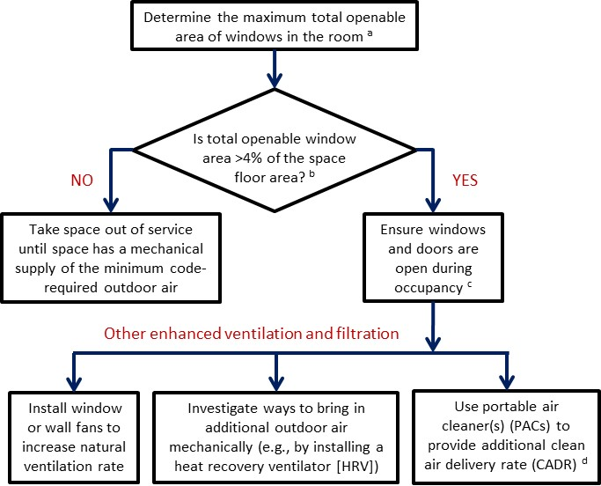

Figure . Flow chart for checking spaces without mechanical ventilation.

**Notes:**

a See Appendix B for a DIY inspection checklist to determine the area of openable windows.

b The [California Building Standards Code (Title 24)](https://www.dgs.ca.gov/BSC/Codes)—in both Part 4 of the California Mechanical Code (CMC) and Part 6 of the California Energy Code (CEC)—requires that buildings with no mechanical supply of outdoor air have windows with a total openable area of at least 4 percent of the floor area [4, 5].

c When weather conditions allow, opening windows and doors can provide fresh outdoor air. See Appendix C for background information on VRs for naturally ventilated classrooms.

d Schools can refer to the SF DPH web page [FAQs: Portable Air Cleaners](https://www.sfdph.org/dph/files/ig/FAQ-Portable-Air-Cleaners.pdf) for detailed instructions on how to properly size and select PACs [6].

**Mechanically ventilated spaces**

If the space is mechanically ventilated, use the following flow chart (Figure 2) to check the space. (Note: even with mechanical ventilation, opening windows and doors can provide additional outdoor air ventilation.) Appendix C provides background information on common types of ventilation and filtration in schools and minimum VR requirements. Appendix D provides a simplified, DIY checklist for operation inspection of classroom HVAC systems. Appendix E describes how to use carbon dioxide (CO2) decay to measure outdoor air VR. For more complete HVAC checklists and operation guidance, schools are encouraged to read the American Society of Heating, Refrigerating and Air-Conditioning Engineers (ASHRAE) guideline on [*Reopening Schools and Universities*](https://www.ashrae.org/technical-resources/reopening-of-schools-and-universities) [7] and the California Coalition for Adequate School Housing (CASH) Maintenance Network’s guidebook on [*Healthy Schools: Cleaning, Disinfecting, Healthy Air Quality, Scheduling and Social Distancing*](http://www.cashnet.org/wp-content/uploads/2020/06/0616020-CASH-CMN-Healthy-Schools-Resource.pdf) [8].

Several guidance documents recommend a target minimum VR of 6 air changes per hour (ACH) to reduce the spread of airborne SARS-CoV-2 [2, 9]. The metric “ACH” is considered preferable to airflow rate (e.g., in cubic feet per minute, cfm) to describe VRs used to control indoor air contaminants, because it scales with room volume (i.e., larger rooms need more ventilation). ACH can be calculated from airflow rate and room volume, using the following equation:

ACH = airflow rate (m3/h)/room volume (m3)

(using International System of Units [SI] units), or (1a)

ACH = airflow rate (cfm) × 60/room volume (ft3)

(using English units) (1b)

The minimum ventilation requirement of 6 ACH can be traced to the 1970 Centers for Disease Control and Prevention (CDC) recommendations for infection control [*Isolation Techniques for use in Hospitals*](https://www.google.com/books/edition/Isolation_Techniques_for_Use_in_Hospital/--xLAQAAIAAJ?hl=en&gbpv=1&dq=isolation+techniques+for+use+in+hospitals&printsec=frontcover) [10]. The manual described a private room as follows: “The room or area should have minimum ventilation of six air changes per hour.” [*Current recommendations*](https://www.cdc.gov/infectioncontrol/guidelines/isolation/index.html) are to provide at least 6 ACH in existing healthcare facilities and 12 ACH in new ones and those undergoing renovation [11]. In addition, if it is not possible to exhaust air from an isolation room directly to the outside, the air may be returned to the air-handling system or adjacent spaces if all air is directed through high-efficiency particulate air (HEPA) filters. Although devised for healthcare settings, these ventilation recommendations can provide a good reference for other workplaces and public spaces where persons with aerosol transmissible infections, such as SARS-CoV-2, may be present.

In addition to outdoor air ventilation, the removal of airborne virus-containing particles from indoor air by HVAC system filters and PACs can be included in calculation of the above-mentioned minimum ACH. However, because the HVAC filters used in general building environments are not true HEPA filters, they only remove a portion of airborne viruses. The total ACH for SARS-CoV-2 removal, ACHTotal, including the combination of outdoor air ventilation, HVAC system filtration, and PAC rates, can be calculated using Equation (2).

ACHTotal = ACHOA + ACHHVAC-Filtration + ACHPAC (2)

where:

ACHOA = outdoor air VR

ACHHVAC-Filtration = SARS-CoV-2 removal rate by HVAC system filtration

ACHPAC = SARS-CoV-2 removal rate by PAC.

This calculation function has been implemented as an output spreadsheet in the Interactive Model of CDPH IAQ’s modeling paper (Appendix 3) [1]. See Appendix F for an example calculation.

Opening windows and doors can further increase outdoor air ventilation for classrooms with mechanical ventilation. See Appendix B for how to determine the area of openable windows in classrooms.

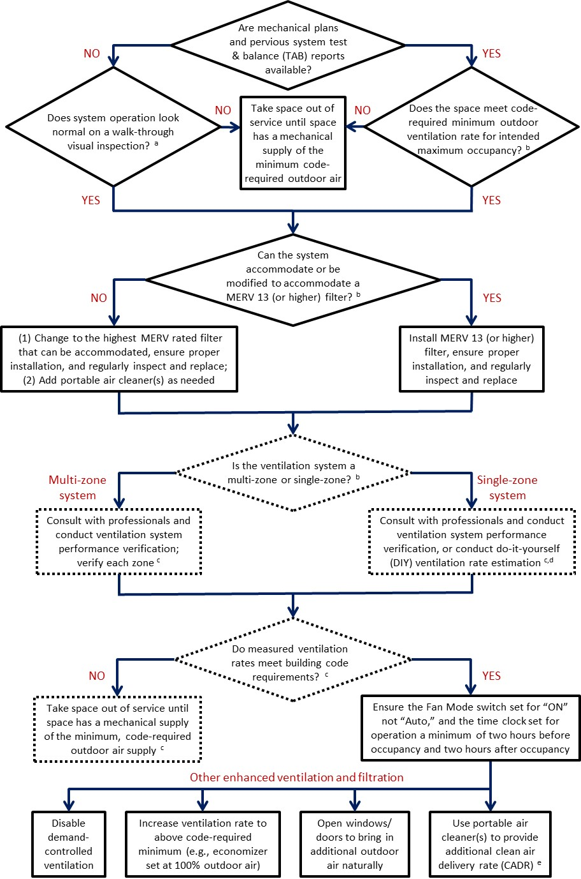

Figure . Flow chart for checking spaces with mechanical ventilation.

**Notes:**

a See Appendix D for a DIY checklist for initial operation inspection of classroom HVAC systems; see the Environmental Protection Agency (EPA)’s web page [Indoor Air Quality Tools for Schools Action Kit](https://www.epa.gov/iaq-schools/indoor-air-quality-tools-schools-action-kit) for a more complete ventilation checklist [12].

b See Appendix C for background information on common types of ventilation and filtration in schools and minimum VR requirements.

c Unless otherwise required, VR measurement and verification are optional as they may not be feasible prior to school reopening.

d DIY VR measurement can be done using a CO2 decay method (Appendix E), a steady-state CO2 method, or a balometer; see the Harvard T.H. Chan School of Public Health’s (HSPH) web page [5 Step Guide to Checking Ventilation Rates in Classrooms](https://schools.forhealth.org/ventilation-guide/) for detailed instructions [9].

e Schools can refer to the SF DPH web page [FAQs: Portable Air Cleaners](https://www.sfdph.org/dph/files/ig/FAQ-Portable-Air-Cleaners.pdf) for detailed instructions on how to properly size and select PACs .

# Appendix A. List of Units of Measure, Acronyms, and Abbreviations of Measure

|  |  |  |  |
| --- | --- | --- | --- |
| **Symbol** | | **Name** | |
| cfm | | cubic foot per minute | |
| ft2 | | square foot | |
| ft3  h  in | | cubic foot  hour  inch | |
| L  lb  lbs | | Liter  pound  pounds | |
| L/s-occupant | | liter per second per occupant | |
| m/s | | meter per second | |
| m2 | | square meter | |
| m3  min | | cubic meter  minute | |
| ppm | | part per million | |
| **Acronym** | **Group or program** | | |
| ASHRAE | American Society of Heating, Refrigerating and Air-Conditioning Engineers | | |
| CASH | California Coalition for Adequate School Housing Maintenance Network | | |
| CDC | Centers for Disease Control and Prevention | | |
| CDPH | California Department of Public Health | | |
| CEC | California Energy Code | | |
| CHPS | Collaborative for High Performance Schools | | |
| CMC | California Mechanical Code | | |
| EPA  HSPH  IAQS  LEED | Environmental Protection Agency  Harvard T.H. Chan School of Public Health  Indoor Air Quality Section  Leadership in Energy and Environmental Design | | |
| SF DPH | San Francisco Department of Public Health | | |
| **Abbreviation** | | | **Meaning** |
| ACH a | | | air changes per hour (also called air change rate) |
| CADR b | | | clean air delivery rate |
| CO2 | | | carbon dioxide |
| COVID-19 | | | CO stands for coronavirus, VI for virus, D for disease, and -19 for the year 2019; previously referred to as “2019 novel coronavirus” or “2019-nCoV” |
| DCV | | | demand control ventilation |
| DIY | | | do-it-yourself |
| DOAS | | | dedicated outdoor air system |
| ERV | | | energy recovery ventilator |
| FCU | | | fan coil unit |
| HEPA | | | high-efficiency particulate air |
| HRV | | | heat recovery ventilator |
| HVAC | | | heating, ventilation, and air-conditioning |
| IAQ | | | indoor air quality |
| MERV c | | | minimum efficiency reporting value |
| PAC | | | portable air cleaner |
| RTU | | | rooftop unit |
| SARS | | | severe acute respiratory syndrome due to SARS-CoV or SARS-CoV-1 |
| SARS-CoV-2 | | | severe acute respiratory syndrome due to SARS-CoV-2 |
| SI | | | international system of units of measure |
| Title 24 | | | California Building Standards Code |
| VAV | | | variable air volume |
| VR | | | ventilation rate |

a **ACH** is a calculated value that allows ventilation standards, guidelines, and comparisons to be made for rooms that have different dimensions or different ventilation systems. It is considered preferable to airflow rate to describe VRs used to control indoor air contaminants, because it scales with room volume (i.e., larger rooms need more ventilation). b **CADR** measures an air cleaner's effectiveness based on room space and the volume of clean air delivered per minute. Commercially available portable air cleaners often have three CADR ratings certified by the Association of Home Appliance Manufacturers (AHAM) [13]. For COVID-19 purposes, use of the CADR rating for “tobacco smoke” (i.e., for particles in the 0.09–1 µm size range) is preferred because research has demonstrated that a significant number of SARS-CoV-2-containing particles could be <0.5 µm [14]. The CADR rating for “tobacco smoke” is typically less than or equal to the CADR for “dust” (i.e., 0.5–3 µm particles), which has been recommended in other guidance documents [2, 6].

c **MERV** is a measurement and reporting scale to rate the performance of HVAC filters for removing particles in the 0.3–10 µm size range, based on an ASHRAE test standard [15]. MERV values range from 1–16. Higher MERV ratings correspond to a greater percentage of particles captured on each pass through a filter, especially for smaller sized particles (i.e., 0.3–1 µm). For COVID-19 purposes, MERV 13 is the recommended minimum; MERV 14 is preferred [7].

# Appendix B. DIY Inspection for Area of Openable Windows in Classrooms

**Purpose**: To determine if classrooms windows have operable openings that meet the code-required, minimum openable area (i.e., 4 percent of the room floor area if there is no mechanical ventilation).

**Note**:

* Title 24 requires that classrooms have windows with a total openable area of at least 4 percent of the floor area or a mechanical ventilation system with an outdoor air ventilation rate of at least 15 cfm/occupant or 0.15 cfm/ft2, whichever is greater. Therefore, this inspection should be conducted in classrooms without mechanical ventilation systems, i.e., those that rely solely on openable windows for ventilation. This inspection may also be conducted in classrooms that have mechanical ventilation, as opening windows can further increase outdoor air ventilation.
* Openable windows can provide a substantial amount of outdoor air depending on how much and often the windows are opened and weather conditions (e.g., wind speed and outdoor air temperature). However, if the window opening is restricted—they cannot be opened at all, openable but the opening is limited (e.g., windows open only partially because of mechanical limiters or because they are stuck), or the windows are obstructed by furniture (e.g., bookshelves, cabinets, or shelving)—then the amount of outdoor air entering a classroom through the windows may be restricted.
* In this section, we assume that English rather than SI units are employed.

The following is guidance for completing the attached DIY Classroom Openable Area Inspection Datasheet (window datasheet).

**What You Need:**

* Tape measure or laser distance meter
* Clipboard and the window datasheet

Blank and example window datasheets follow this section and also are available as Excel spread sheets (in both SI and English units).

**Procedure for Determining the Area of Openable Windows**

**1) Measure classroom floor area.**

Measure in feet the width and length of the classroom, multiply to determine the floor area, and record on the window datasheet.

**Note**: If the classroom has an adjacent area, separated by a wall, with permanently unobstructed openings (i.e., no doors), the classroom and adjacent space may be considered one room for purposes of calculating the window open area provided that openings between the rooms have a total area of not less than 8 percent of the adjacent space floor area or 25 ft2, whichever is greater [4].

**2) Determine if windows are obstructed.**

For each window, record whether the windows are obstructed or unobstructed.

**3) Calculate the openable window area for each unobstructed window.**

For each unobstructed window, open to the maximum possible degree and record the type of window (e.g., slider, casement, or awning), the opening dimensions, and the maximum openable area (ft2).

See below for calculation methods for the types of windows commonly found in classrooms.

Sliding windows For windows with vertical sliders (e.g., single- or double-hung windows) and windows with horizontal sliders, measure and record the opening width and height of the opening in inches. Multiply the width by the height and divide by 144, which converts square inches to square feet.

Awning windows For awning windows, which have a section that tilts out along a horizontal hinge, calculate and record the openable area as for sliding windows. The swing-open distance is measured as the perpendicular distance from the awning window to the edge of the opening opposite the hinge, as shown in Figure 3. Note that the amount that a window opens determines where the measurement should be taken.

Figure of three example casement windows showing 20%, 50%, and 100% swing open distances

Figure . Swing open distance measurement for casement and awning windows.

Casement windows For casement windows, which have a section that tilts out along a vertical hinge, calculate and record the openable area as for sliding windows. The swing-open distance is measured similarly as for awning windows but using the perpendicular distance from the casement window to the edge of the opening opposite the hinge.

**4) Calculate the total openable window area.**

Sum the openable area from each unobstructed window and record the total openable window area. Divide this total area by the floor area, multiply by 100, and record the total openable window area as a percentage of the floor area.

**Note:** If the total area is less than the code-required 4 percent, windows need to be repaired or upgraded to achieve at least the required minimum (e.g., remove obstructions, adjust limiters on window openings, and free stuck windows) or a mechanical supply of at least the code-required minimum outdoor air needs to be provided.

**5) Sign and date the window datasheet.**

**Window Openable Area Inspection Datasheet** (window datasheet)

Classroom Name:

Floor Area (ft2):

|  |  |  |  |  |
| --- | --- | --- | --- | --- |
| Window Maximum Openable Area | | | | |
| Window number | Window obstructed (Yes/No) | Width or swing-open distance (in) | Height or swing-open distance (in) | Openable area (ft2) |
| 1 |  |  |  |  |
| 2 |  |  |  |  |
| 3 |  |  |  |  |
| 4 |  |  |  |  |
| 5 |  |  |  |  |
| 6 |  |  |  |  |
| 7 |  |  |  |  |
| 8 |  |  |  |  |

Total openable area for unobstructed windows (ft2)

Total openable area (ft2) as a percentage of floor area (ft2)

Does the classroom have a total openable window area of at least 4 percent of the floor area?

☐ Yes—No further action required; open windows fully whenever possible to increase outdoor air ventilation.

☐ NO—Make necessary window repairs or install a mechanical supply of outdoor air if none present.

**Note:** Title 24 requires that classrooms have windows with a total openable area of at least 4 percent of the floor area or a mechanical ventilation system with an outdoor air ventilation rate of at least 15 cfm/occupant or 0.15 cfm/ft2, whichever is greater.

Inspector’s name:

Date:

**Window Openable Area Inspection Datasheet (EXAMPLE)**

Classroom Name: Room 101

Floor Area (ft2): 960

|  |  |  |  |  |
| --- | --- | --- | --- | --- |
| Window Maximum Openable Area | | | | |
| Window number | Window obstructed (Yes/No) | Width or swing-open distance (in) | Height or swing-open distance (in) | Openable area (ft2) |
| 1 | N | 36 | 34 | 8.50 |
| 2 | N | 36 | 33 | 8.25 |
| 3 | N | 36 | 32 | 8.00 |
| 4 | N | 36 | 33 | 8.25 |
| 5 | N | 36 | 34 | 8.50 |
| 6 | N | 36 | 34 | 8.50 |
| 7 |  |  |  |  |
| 8 |  |  |  |  |

Total openable area for unobstructed windows (ft2) 50

Total openable area (ft2) as a percentage of floor area (ft2) 5.2%

Does the classroom have a total openable window area of at least 4 percent of the floor area?

☑ Yes—No further action required; open windows fully whenever possible to increase outdoor air ventilation.

☐ NO—Make necessary window repairs or install a mechanical supply of outdoor air if none present.

**Note:** Title 24 requires that buildings with no mechanical supply of outdoor air have windows with a total openable area of at least 4 percent of the floor area or a mechanical ventilation system with an outdoor air ventilation rate of at least 15 cfm/occupant or 0.15 cfm/ft2, whichever is greater.

Inspector’s name: Luis Martinez

Date: February 10, 2021

# Appendix C. Common Ventilation and Filtration Equipment in California Schools

**Mechanical Ventilation Equipment**

Mechanically ventilated classrooms use either “multi-zone” or “single-zone” systems. Multi-zone systems are centralized, relatively large air-handling units that serve multiple classrooms with a remote fan and compressor. In single-zone systems, HVAC units are often either packaged rooftop units (RTUs) or wall-mounted units serving only one or a few classrooms. Wall-mounted units—such as unit ventilators with integrated outdoor air ventilation and filtration, heat pumps with dedicated outdoor air system (DOAS), or fan coil units (FCUs) with DOAS—are used more often in relocatable classrooms. For example, HVAC systems in these classrooms, per a 2004 California study, were typically packaged wall units with teacher-controlled in-room thermostats [16]. A 2020 study of California schools with retrofitted HVAC equipment also reported that relocatable classrooms predominately used wall-mounted, single-package, HVAC systems, while permanent classrooms generally had RTUs [17]. It should be noted that some classrooms have units that only heat or cool the air within a space, with no outdoor air intake (e.g., split systems or FCUs without DOAS). These classrooms do not provide mechanical outdoor air ventilation and rely entirely on openable windows for natural ventilation.

For all types of HVAC equipment, a fixed position ventilator/damper is the basic control for the mechanical ventilation system, where the position of the outdoor air damper or the size of the opening is fixed so as to provide the indoor space with (at least) the minimum outdoor air VR specified in the design code. Additional features for optimizing both energy efficiency and indoor air quality (IAQ) are often available, either as standard or optional upgrades depending on the product brand and model. Such features include variable air volume (VAV) systems, airside economizers, energy or heat recovery ventilators (ERVs or HRVs), and demand control ventilation (DCV) systems. These are explained further below.

* VAV: Traditionally, single-zone VAV systems have been used for large, densely occupied zones that have variable cooling loads. However, due to increased focus on energy efficiency, a single-zone VAV currently is used more often in K–12 classrooms, and also is offered in smaller equipment, such as packaged RTUs or direct expansion split systems, fan-coils, classroom unit ventilators, and water-source heat pumps [18]. In contrast with a constant supply airflow rate delivered by a conventional constant air volume system, the supply airflow rate delivered by a VAV system can adjust to demand. With VAV systems, steps need to be taken to ensure that the amount of outdoor air is not reduced below applicable standards when supply air is reduced during part-load conditions.
* Economizer: Economizers use outdoor air to provide free cooling. An airside economizer is now a typical feature in unit ventilators and RTUs. With an economizer, the outdoor air damper can open fully and deliver up to 100 percent outdoor air under favorable weather conditions.
* ERVs and HRVs: An ERV transfers heat and moisture between exhausted room air and incoming outdoor air, thereby reducing the energy required to condition the incoming air. An HRV transfers heat only. An ERV or HRV option is commonly offered in wall-mount units.
* DCV: DCV, using CO2 sensing, varies the outdoor air supply in response to the indoor CO2 concentration, to ensure that the maximum concentration remains below a set threshold, generally 1000–1200 ppm. A DCV system always incorporates a minimum outside air setting to dilute building-emitted contaminants during low-occupancy periods. Classroom CO2 level can be displayed on a monitor (i.e., readily visible to teachers) or directly transmitted to the school’s facility energy management system. Both RTU and wall-mount unit manufacturers offer DCV as an add-on feature.

Limited data is available on the prevalence of various ventilation system types in California schools or on trends in changes over the years. Chan et al. recently conducted a survey in 104 mechanically ventilated California classrooms and reported the frequency of occurrence for different types of ventilation equipment, including four commonly used technology types [17] (Table 1).

|  |  |
| --- | --- |
| Table 1. Common ventilation equipment found in 104 mechanically ventilated California classrooms with single-zone systems | |
| Technology type | Number (percentage) |
| ERVs a | 5 (4.8%) |
| Fixed position ventilators | 19 (18%) |
| DCVs b | 25 (24%) |
| Economizers c | 74 (71%) |

**Note:**

a ERVs were all in wall-mount units and not RTUs (although adding an ERV to an RTU is possible).

b DCVs were all installed in RTUs and not in wall-mount units (although wall-mount unit manufacturers do offer this option). In all the systems in this study sample, the actuated damper provided both DCV and economizer functions.

c Economizers were common in both RTUs and wall-mount units.

Another factor that may influence the operation of HVAC systems is system noise. Research has found that this is often the most significant source of classroom noise, and cooling system type usually determines the level of overall mechanical noise [19]. Because relocatable classrooms typically have packaged wall units with fans (and sometimes also a compressor) attached outside to one end of the classroom, they can transmit unacceptable ventilation noise and vibration that results in teachers turning off the ventilation system. For example, a 2004 California classroom study found that 60 percent of teachers in relocatable classrooms turned off the mechanical ventilation at times because of the noise (thus providing no outside air), whereas this occurred less often in traditional classrooms [20]. Some manufacturers of packaged wall units for relocatable classrooms have improved the design of systems manufactured after 2005 to reduce transmission of noise and vibration.

**Code-required Minimum VR**

For a mechanically ventilated space, Title 24—in both Part 4 of the California Mechanical Code (CMC) and Part 6 of the California Energy Code (CEC)—lists code-required minimum outdoor air VRs for a total of 14 space types in educational facilities [4, 5]. However, the two code requirements sometimes differ. For example, the CEC-required outdoor air VRs for classrooms (ages 5–8 and 9 and older) are 15 cfm/occupant or 0.15 cfm/ft2, whichever is greater. These values are 3 percent higher than the CMC-required rates for classrooms of ages 5–8 and 12 percent higher for classrooms of age 9 and older, using the default occupancies specified in the CMC code. To ensure the recommended 6-ft physical distance between occupants during the COVID-19 pandemic, actual occupant density may be less than the default value specified in the CMC code. Although VR per occupant is a better indicator of ventilation condition in terms of reducing airborne viral transmission, it should be noted that reducing classroom occupancy does not mean that the code-specified minimum outdoor VR can always be proportionally reduced. This is because the specified minimum is also influenced by floor area (to dilute pollutants of concern emitted from building materials, furniture, and indoor products), and this does not change with reduced occupancy.

**HVAC Filtration**

HVAC filters are available in a variety of Minimum Efficiency Reporting Value (MERV) ratings (i.e., MERV 1 through MERV 16), dimensions (e.g., differing lengths, widths, and 1-, 2-, 4-, 6-, or 12-inch depths), media types (e.g., fiberglass or synthetic media), and design configurations (e.g., panel, pleat, mini-pleat, or bag). In terms of reducing indoor airborne particle concentrations, high-efficiency filters (either installed in a centralized HVAC system to treat recirculated air or included in PACs) can be considered to provide “equivalent” outdoor air ventilation. While outdoor air ventilation equally dilutes the concentration of all gases and all sizes of airborne particles, the “equivalent” clean air provided by filtration for airborne viruses depends on the particle removal efficiency of the filter for the size distribution of the virus-containing particles. It is therefore important to choose the “right” filter and to optimize the combination of ventilation and filtration to achieve the desired overall system performance.

Almost no peer-reviewed information is available on the frequency of use of various MERV filter grades and filter rack depths in California schools. MERV 8 filters in 1- and 2-inch deep filter frames appear to be the most common for classrooms with small RTUs, unit ventilators, heat pumps, and FCUs, while MERV 13 filters appear to be found more frequently in school buildings with larger air handling units and packaged air conditioners. If a school building has been Leadership in Energy and Environmental Design (LEED) or Collaborative for High Performance Schools (CHPS) certified, the filters should already be MERV 13. In California, Title 24-2019 Energy Efficiency Standards now require a MERV 13 or higher filter [5]. CASH and CHPS school reopening guidance also recommend at least a MERV 13 filter [9, 20], as does ASHRAE guidance if higher efficiency filters do not adversely impact system operation [7].

Upgrading to MERV 13 can be relatively inexpensive compared to increasing outdoor air VR to well above the code-required minimum, depending on the current filter rack depth. If the existing filters and filter racks are 2 inch or deeper, replacing a MERV 8 with a MERV 13 filter in most systems will not cause a significant reduction of the supply airflow rate. Many commercially available MERV 13 filters of 2-inches or deeper have pressure drops only slightly higher (i.e., ≤0.1 inches water gauge or ≤25 pascals) than those of MERV 8 filters at air speeds of 300–500 feet per minute (1.5–2.5 m/s). Such a slight increase of pressure drop typically will not cause a significant reduction in the supply airflow rate. The fan performance curve (i.e., design static pressure vs. flow rate) can be checked as needed to verify that there is no significant airflow reduction due to a filter upgrade. However, if the existing filters and filter racks are only 1-inch deep, finding a true 1-inch MERV 13 filter with a low pressure drop can be difficult. This is because commercially available 1-inch MERV 13 filters often use electrostatically charged media, which may lose efficiency quickly after installation. Still, upgrading to a MERV 13 filter may be feasible if a 1-inch rack can be modified to accept a 2-inch filter.

**Note:** When considering filtration devices, it is best to select only those with MERV (or for PACs, CADR) ratings. Some other types of air cleaning devices, although commercially available and marketed as effective and safe for indoor use in response to the COVID-19 outbreak, have unproven efficacy, and some (i.e., ozone generators and ionization devices) may even produce harmful pollutants [21].

**VRs from Opening Windows for Naturally Ventilated Classrooms**

There are two driving forces for natural ventilation: wind pressure and stack (or buoyancy) pressure due to indoor-outdoor air temperature difference. Therefore, the amount of outdoor air entering through windows varies with time and location, depending on the outdoor wind speed and the indoor-outdoor temperature difference. For spaces with standard window and room geometry, if the opening area and height, wind speed, and indoor and outdoor temperature difference are known, the natural VR can be roughly estimated using simplified equations (see [Natural Ventilation for Infection Control in Health-Care Settings](https://www.ncbi.nlm.nih.gov/books/NBK143285/)) [22]. As for the actual operational conditions of windows and VRs in naturally ventilated classrooms, currently available information is limited, and more research is needed.

# Appendix D. Initial DIY Operation Inspection for Classroom HVAC Systems

**Purpose**: To determine if HVAC systems are operable and are delivering outdoor and appropriately filtered air to a classroom.

**Caution**: This inspection does not ensure that the desired quantity of outdoor air is being delivered to a space. To determine the quantity of delivered outdoor air, HVAC airflow rate measurements (see ASHRAE [7] and HSPH [9] recommendations) or a CO2 decay test are required (see Appendix E).

The following is guidance for completing the following DIY checklist to assess important aspects of HVAC operation.

**What You Need:**

* Airflow indicator (e.g., a flexible piece of ribbon or tissue paper)
* Clipboard and the Classroom HVAC System Operation Inspection Checklist

**1) Inspect overall system operation**

**Identify the HVAC system that serves a classroom**

For many classrooms the HVAC system that serves the space will be obvious if there is a dedicated system such as a wall-mounted unit ventilator. For classrooms with a rooftop unit (RTU), the RTU on the roof that is closest to the space is likely the system that serves the space. To confirm that a specific RTU serves a space, turn it on and off while observing if air is coming out of the supply air diffusers.

**Note:** Attaching an airflow indicator to a supply air diffuser provides “at a glance” feedback that the HVAC system is operating. The RTU fan typically can be turned on and off at the room thermostat using the fan mode switch “Auto/On.” Record the name and location of the HVAC system on the checklist.

**Determine if outdoor air is entering the HVAC outdoor air intake**

With the HVAC system operating, use an airflow indicator to determine if air is entering the outdoor air intake, and record on the checklist. Typically, the outdoor air intake is in a section of the HVAC system upstream of the filters and often has a sheet metal canopy to protect it from rain. Figure 4 shows the outdoor air inlet for a typical rooftop HVAC system. If no air is entering, a mechanical contractor will need to inspect and repair the system.

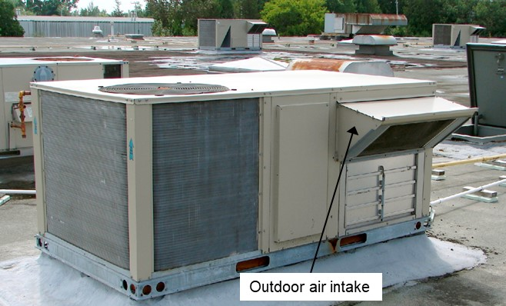

Figure 4. Outdoor air inlet for a typical rooftop HVAC system.

**Determine if supply air is coming out of each of the supply air diffusers of the HVAC system**

With the HVAC system operating, use an airflow indicator to determine if air is entering from each of the supply air diffuser and record on the checklist. Typically, an RTU has ceiling “supply air” diffusers (often with deflection blades) as well as “return air” inlets (with perforated plates). Figure 5 shows an airflow indicator to determine that air is being delivered from a supply air diffuser.

If air is not visibly entering a classroom from each of the supply air diffusers, a mechanical contractor will need to inspect and repair the system.

**Note:** Seeing that air visibly enters a room simply shows that the system is operating but does not ensure that the desired amount of outdoor air is being supplied (see Appendices D and E).

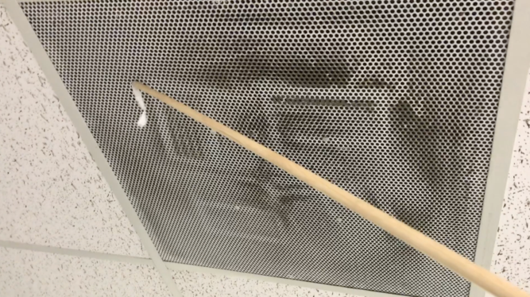

Figure 5. Checking that air is entering the room from a ceiling supply air diffuser with an airflow indicator.

**2) Inspect the HVAC filters**

Determine the filter’s Minimum Efficiency Reporting Value (MERV) rating and filter condition, and record on the checklist. With the HVAC system off, locate and open the filter slot (typically a 1–4-inch deep slot with a removable cover). Remove the filter and record the MERV rating on the checklist. If the MERV rating is not labelled, record the manufacturer and model number and look up the MERV rating online. The recommended minimum efficiency is MERV 13. If the filter slot is ≥2 inches deep, a MERV 13 filter with a low air pressure drop can be installed in most HVAC systems.

Determine if the filters are installed in the filter rack without significant air bypass around the edges. Replace any missing or damaged filters and seal any gaps in the filter rack, e.g., with a sheet metal spacer.

Replace the filters if they are visibly overloaded with particulate matter (dust).

**3) Inspect the HVAC fan controls**

Single-zone HVAC systems often have a Fan Mode switch integrated with the wall thermostat. The Fan Mode switch can be set for “Auto” or “On.” When the switch is set for “Auto,” the HVAC fan only operates when the thermostat calls for heating or cooling. To ensure continuous operation of the fan and thus delivery of outdoor and filtered air, ensure that the switch is set for “On” and record on the checklist. Figure 6 shows a thermostat with the fan mode switch set to “On”. The fan controls for larger, multi-zone HVAC systems most often are integrated with the Building Automation System, and not located on the wall.

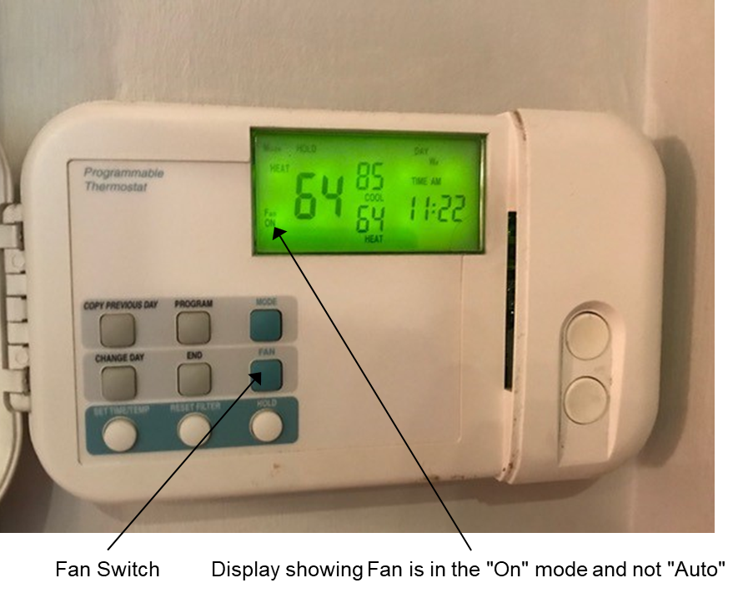

Figure 6. Thermostat with the fan mode switch set to “On.”

**4) Inspect the HVAC time clock**

Single-zone HVAC systems often have a time clock integrated with a wall thermostat that starts and stops them at programmed times. HVAC time clocks for larger, multi-zone HVAC systems most often are integrated with the Building Energy Management System. The time clock should start HVAC operation two hours before and after students, teachers, and custodial staff initially enter and finally leave the room.

Record the normal occupancy start and stop times along with the HVAC time clock start and stop times on the checklist.

**5) Sign and date the checklist**

**Classroom HVAC System Initial Operation Inspection Checklist**

Classroom Name:

System Operation

Identify HVAC system serving the space. System ID and Location:

Turn system on and determine each of the following:

Yes No

☐ ☐ Outdoor air is entering the HVAC outdoor air intake

☐ ☐ Supply air is coming out each of the HVAC supply air diffusers

Air Filtration—Determine each of the following:

☐ What is the filter MERV rating: (targeting MERV 13 or higher)

☐ ☐ Filters are installed in filter rack without significant air bypass

☐ ☐ Filters are not overloaded with particulate matter (dust)

Fan Control—HVAC system thermostat has the Fan Mode switch set for “ON” not “AUTO”

☐ ☐ Fan Mode switch is set for “ON”

Time Clock

Normal Occupancy Start Time: HVAC Start Time:

Normal Occupancy Stop Time: HVAC Stop Time:

☐ Time clock is set to start system two hours before occupancy and to stop system two hours after occupancy (including time needed to clean room).

**Note:** If a box is checked “NO,” conduct necessary repairs before occupancy.

Inspector’s name:

Date:

# Appendix E. Using CO2 Decay to Estimate VR—Method Description and Test Procedure

Increasingly, California classrooms are equipped with CO2 monitoring devices (i.e., display only or also with datalogging capability), due to the increased availability and improved performance of low-cost sensors. This has made real-time, classroom CO2 measurement more feasible.

There are several ways to estimate VRs using measured indoor CO2 concentration (occupant generated or from a CO2 source) and measured (or assumed) outdoor concentration [23-25]. The steady-state method (CO2 rise to a steady, unchanging concentration) and the concentration decay method (rate of CO2 decline) are most commonly used. Both methods assume that the measured CO2 concentration represents the room average (i.e., the room air is well mixed, and the CO2 concentration is similar throughout). The CO2 decay method (outlined below) estimates VR more accurately than the steady-state method, because the later depends on assumed occupant CO2 generation rate (which varies substantially by occupant age, gender, weight, and metabolic activity) [1].

When using exhaled breath as the source, CO2 decline can be measured over a period of time (e.g., 30 min) after occupants leave (e.g., at the end of school day), and the outdoor air change rate (ACH) can be calculated directly [9]. This rate can then be multiplied by the room air volume to calculate the outdoor airflow rate (cfm or m3/h). Knowing the airflow rate, maximum occupancy, and floor area, the VR per occupant (cfm or L/s-occupant) and per floor area (cfm/ft2 or L/s-m2) can be determined, see following procedure. Alternatively, in unoccupied rooms, CO2 gas can be released (e.g., from a compressed gas cylinder or dry ice) to purposely generate a high initial concentration (e.g., 2000 ppm), and the same measurement and calculation procedure can then be applied.

If a classroom remains occupied (e.g., by a teacher or custodian), the outdoor ACH estimated from CO2 decay will be less than the true ACH because the method assumes no indoor CO2 sources. Such deviation due to continued occupancy is influenced mainly by the measurement period, the initial CO2 concentration, and the actual ACH, and to a lesser extent, by the outdoor CO2 concentration. For example, in a typical classroom defined in the CDPH IAQS modeling paper (i.e., 27 occupants, 89.3 m2 floor area, 3 m ceiling, and code-required minimum 2.54 ACH outdoor air) [1], with an initial CO2 concentration of 1500 ppm and one occupant remaining, the estimated VR will be only ~5 percent lower than the true VR if the final concentration is measured at 30 min. In general, even if an occupant remains, the estimated VR is still a sufficient and conservative approximation of the true ACH.

**Procedure for Measuring Classroom Outdoor Air VR Using a CO2 Decay Test**

**Purpose**: To determine the delivery of outdoor air from a ventilation system.

**Caution**: This procedure provides a measurement of the outdoor air VR in a single classroom with a single mechanical ventilation system. Spaces with multi-zone HVAC systems that serve more than one classroom require a different test method.

**What You Need:**

* CO2 meter
* Cylinder of CO2 (e.g., a 20-lb aluminum cylinder) or a cooler with dry ice pellets; approximately 1–2 lbs of CO2 are required for each classroom test.
* Box fan and extension cord
* Tape measure or laser distance meter
* Clipboard, pen, calculator, watch
* Classroom CO2 Decay Ventilation Measurement Datasheet

Blank and example CO2 datasheets follow this section and also are available as excel spread sheets (in both SI and English units).

**How to Measure CO2 Concentration Decay**

1. Indoors, close all windows and doors.
2. Determine the maximum classroom occupancy (number of persons), measure and record the room dimensions, and calculate and record the floor area and air volume. If the ceiling is sloped, use the average ceiling height to calculate air volume.
3. Outdoors, turn on the CO2 meter, place it out of direct sunlight, let equilibrate for 5 min, and record time and the initial outdoor concentration (Coutdoor initial).
4. Indoors, place the CO2 meter in the center of the room and let equilibrate for 5 min.
5. Place the CO2 source at one end of the room with the box fan positioned behind the tank or cooler blowing air to the opposite side of the room. Turn the box fan on at high speed.
6. Slowly open the CO2 tank valve until you hear that gas is flowing. Or, if using dry ice, open the cooler lid. Do not touch dry ice with bare hands, to avoid the risk of burns.
7. When the room CO2 concentration reaches approximately 2000 ppm, close the tank valve or cooler lid, remove from the room, and leave the box fan running.
8. Record the initial indoor CO2 concentration (Cindoor initial) and time (Tinitial), then leave the room.
9. After 30 min have elapsed, return to the room and record the final concentration (Cindoor final) and time (Tfinal).

**Note:** If the CO2 concentration is not recorded at 30 min (e.g., 1 or 2 min before or after 30 min have elapsed), the ACH can still be calculated, just enter the time and use the actual number of minutes that elapsed since the initial concentration measurement.

1. Outdoors, place the CO2 meter out of direct sunlight, let equilibrate for 5 min, and record time and the final outdoor concentration (Coutdoor final).
2. Calculate and record the average outdoor CO2 concentration (Coutdoor average): sum the initial and final concentrations and divide by two.

**Note:** If occupant-generated CO2 is used to establish the initial CO2 concentration, eliminate Steps 5–7 and apply the rest of procedure. To reduce estimation uncertainty, an initial indoor CO2 concentration >1000 ppm or a shorter measurement end time (e.g., 15 min) is recommended.

**How to Calculate the Outdoor Air VR**

* Calculate and record the elapsed time (min) between the initial and final indoor concentration measurements.

Telapsed = Tfinal − Tinitial

* Calculate and record the initial and final indoor concentrations corrected for background outdoor concentration (Ccorrected initial and Ccorrected final).

Ccorrected initial = Cindoor initial − Coutdoor average

Ccorrected final = Cindoor final − Coutdoor average

* If the elapsed time is 30 min, use the attached look-up table to estimate outdoor ACH from the concentration ratio (Ccorrected final) / (Ccorrected initial). Otherwise, calculate and record the outdoor ACH.

ACH = Ln (Ccorrected initial / Ccorrected final) / (Telapsed / 60)

* Calculate and record the outdoor airflow rate (cfm).

cfm = ACH × room air volume (ft3) / 60

* Calculate and record the outdoor air flow rate per occupant (cfm/occupant):

cfm/occupant = cfm / maximum number of persons

* Calculate and record the outdoor air flow rate per room floor area (cfm/ft2):

cfm/ft2 = cfm / room floor area (ft2)

**Note:**

* For mechanically ventilated classrooms (including classrooms for both ages 5–8 and 9 and older), the California code-required minimum outdoor air VRs are 15 cfm/occupant or 0.15 cfm/ft2, whichever is greater.
* If the outdoor CO2 concentration cannot be measured, assume an outdoor concentration of 400 ppm. This assumption results in a sufficient but conservative estimation of VR (i.e., a calculated VR that is 10–20 percent lower than the true VR), because actual outdoor CO2 concentrations are usually higher than 400 ppm [26].

**CO2 Ventilation Test Look-Up Table**

Use this table to estimate the outdoor ACH from the ratio of final/initial concentrations.

**Note:**

* For this table, Cindoor final must be measured at 30 min following Cindoor initial. If not, use the following equation.

ACH = Ln (Ccorrected initial / Ccorrected final) / ((Tfinal − Tinitial) / 60)

* If the measured concentration ratio is in between two values of this table, use the average of the corresponding two ACH values.

|  |  |  |  |
| --- | --- | --- | --- |
| (Ccorrected final)/  (Ccorrected initial) | Outdoor air ACH | (Ccorrected final)/  (Ccorrected initial) | Outdoor air ACH |
| 0.88 | 0.3 | 0.48 | 1.5 |
| 0.86 | 0.3 | 0.46 | 1.6 |
| 0.84 | 0.3 | 0.44 | 1.6 |
| 0.82 | 0.4 | 0.42 | 1.7 |
| 0.80 | 0.4 | 0.40 | 1.8 |
| 0.78 | 0.5 | 0.38 | 1.9 |
| 0.76 | 0.5 | 0.36 | 2.0 |
| 0.74 | 0.6 | 0.34 | 2.2 |
| 0.72 | 0.7 | 0.32 | 2.3 |
| 0.70 | 0.7 | 0.30 | 2.4 |
| 0.68 | 0.8 | 0.28 | 2.5 |
| 0.66 | 0.8 | 0.26 | 2.7 |
| 0.64 | 0.9 | 0.24 | 2.9 |
| 0.62 | 1.0 | 0.22 | 3.0 |
| 0.60 | 1.0 | 0.20 | 3.2 |
| 0.58 | 1.1 | 0.18 | 3.4 |
| 0.56 | 1.2 | 0.16 | 3.7 |
| 0.54 | 1.2 | 0.14 | 3.9 |
| 0.52 | 1.3 | 0.12 | 4.2 |
| 0.50  (continued) | 1.4 | 0.10 | 4.6 |

**Classroom CO2 Decay Ventilation Measurement Datasheet**

Classroom Name:

Floor Area (ft2):

Ceiling Height (ft):

Volume (ft3):

Maximum Number of Occupants:

Location Time CO2 Concentration (ppm)

Outdoor Coutdoor initial

Coutdoor final

Indoor Cindoor initial

Cindoor final

Coutdoor average

Ccorrected initial (Cindoor initial − Coutdoor average)

Ccorrected final (Cindoor final − Coutdoor average)

Concentration Ratio (Ccorrected final) / (Ccorrected initial)

Tinitial − Tfinal (elapsed minutes)

ACH: (ACH = Ln (Ccorrected initial / Ccorrected final) / (Telapsed / 60))

cfm: (cfm = ACH × room air volume (ft3) / 60)

cfm/occupant: (cfm/occupant = cfm / maximum number of persons)

cfm/ft2: (cfm/ft2 = cfm / room floor area (ft2))

Does the classroom meet the California code-required minimum outdoor air VR?

☐ Yes—No further action required.

☐ NO—Make necessary ventilation system checks and repair equipment as required to achieve minimum outdoor air VR.

**Note:** For mechanically ventilated classrooms, the California code-required minimum outdoor air VRs are 15 cfm/occupant or 0.15 cfm/ft2, whichever is greater.

Inspector’s name:

Date:

**Classroom CO2 Decay Ventilation Measurement Datasheet (EXAMPLE)**

Classroom Name: Room 101

Floor Area (ft2): 960

Ceiling Height (ft): 9

Volume (ft3): 8640

Maximum Number of Occupants: 27

Location Time CO2 Concentration (ppm)

Outdoor Coutdoor initial 10:14 433

Coutdoor final 11:23 449

Indoor Cindoor initial 10:37 1063

Cindoor final 11:07 546

Coutdoor average 441

Ccorrected initial (Cindoor initial − Coutdoor average) 622

Ccorrected final (Cindoor final − Coutdoor average) 105

Concentration Ratio (Ccorrected final) / (Ccorrected initial) 0.17

Tinitial − Tfinal (elapsed minutes) 30

ACH: 3.6 (ACH = Ln (Ccorrected initial / Ccorrected final) / (Telapsed / 60) = Ln (622/105)/(30/60))

cfm: 512 (cfm = ACH × room air volume (ft3) / 60 = 3.6 × 8640 /60 )

cfm/occupant: 19 (cfm/occupant = cfm / maximum number of persons = 512 / 27)

cfm/ft2: 0.53 (cfm/ft2 = cfm / room floor area (ft2) = 512 / 960)

Does the classroom meet the California code-required minimum outdoor air VR?

☑ Yes—No further action required.

☐ NO—Make necessary ventilation system checks and repair equipment as required to achieve minimum outdoor air VR.

**Note:** For mechanically ventilated classrooms, the California code-required minimum outdoor air VR are 15 cfm/occupant or 0.15 cfm/ft2, whichever is greater.

Inspector’s name:

Date:

# Appendix F. Example Calculation of Total ACH for Removing Virus-containing Particles

The following is an example calculation for a typical classroom defined in CDPH IAQ’s modeling paper (i.e., with 27 occupants, floor area of 89.3 m2, and ceiling height of 3 m) [1]. Appendix 3 in this paper has an interactive spreadsheet that calculates ACHTotal, from ACHOA, ACHHVAC-Filtration, and ACHPAC.

For the defined reference case (i.e., with the code-required minimum outdoor air VR, a MERV 8 filter, 6 ACH of supply air, and no PACs) [1], the calculated total ACH for removing virus-containing particles is 4.14 ACH (under the given model assumptions and limitations):

ACHOA = 2.54 ACH (outdoor ventilation airflow rate = 27 occupants × 7 L/s-occupant or 15 cfm/occupant = 680 m3/h or 405 cfm)

ACHHVAC-Filtration = 1.60 ACH (MERV 8 removal of SARS-CoV-2 particles)

ACHPAC = 0 ACH

ACHTotal = 2.54 +1.60 + 0 = 4.14 ACH

Thus, to achieve a minimum ACHTotal of 6 ACH for this classroom scenario, an additional 1.86 ACH, or 498 m3/h (i.e., 1.86 ACH × 89.3 m2 × 3 m) or 293 cfm, is required. This additional removal of airborne particles can be provided by increasing the outdoor ventilation airflow rate, improving the HVAC air filtration rate, or adding PACs with total Clean Air Delivery Rates (CADRs) for “tobacco smoke” ≥ 498 m3/h (or 293 cfm).

**Acknowledgements**

The project was funded by the U.S. Centers for Disease Control and Prevention (CDC) through a COVID-19 Crisis Response Cooperative Agreement (Grant Number: 6 NU90TP922071-01-03). We thank CDC for providing this support.

**References**

1. CDPH, *The role of building ventilation and filtration in reducing risk of airborne viral transmission in schools, illustrated with SARS-CoV-2*. 2020: <https://www.cdph.ca.gov/Programs/CCDPHP/DEODC/EHLB/IAQ/CDPH%20Document%20Library/IAQ%20paper%20on%20school%20ventilation%20filtration%20viral%20transmission.pdf>.

2. SFDPH. *Interim Guidance: Ventilation During the COVID-19 Pandemic*. 2020 20 October 2020; Available from: <https://www.sfdph.org/dph/files/ig/COVID-19-Ventilation-Guidance.pdf>.

3. CDC. *Ventilation in Buildings*. 2020; Available from: <https://www.cdc.gov/coronavirus/2019-ncov/community/ventilation.html>.

4. CEC, *2019 Building Energy Efficiency Standards*. 2019, California Energy Commission: <https://www.energy.ca.gov/programs-and-topics/programs/building-energy-efficiency-standards/2019-building-energy-efficiency>.

5. CBSC, *Building Standards Code, Part 4 - California Mechanical Code*, in *24*. 2019, <http://epubs.iapmo.org/2019/CMC/index.html#p=20>: California Code of Regulations.

6. SFDPH, *FAQs: Portable Air Cleaners*. 2020, San Francisco Department of Public Health: <https://www.sfdph.org/dph/files/ig/FAQ-Portable-Air-Cleaners.pdf>.

7. ASHRAE. *Reopening of Schools and Universities*. 2020; Available from: <https://www.ashrae.org/technical-resources/reopening-of-schools-and-universities>.

8. CASH, *Healthy Schools: Cleaning, Disinfecting, Healthy Air Quality, Scheduling and Social Distancing*. 2020, Coalition for Adequate School Housing Maintenance Network: <http://www.cashnet.org/wp-content/uploads/2020/06/0616020-CASH-CMN-Healthy-Schools-Resource.pdf>.

9. HSPH. *Five Step Guide to Checking Ventilation Rates in Classrooms*. 2020; Available from: <https://schools.forhealth.org/ventilation-guide/>.

10. Siegel, J.D., et al., *Guideline for Isolation Precautions: Preventing Transmission of Infectious Agents in Health Care Settings.* Am J Infect Control, 2007. **35**(10 Suppl 2): p. S65-164.

11. Siegel, J., et al. *Guideline for Isolation Precautions: Preventing Transmission of Infectious Agents in Healthcare Settings*. 2019 July 2019; Available from: <https://www.cdc.gov/infectioncontrol/guidelines/isolation/index.html>.

12. USEPA. *Ventilation Checklist from Indoor Air Quality Tools for Schools*. Available from: <https://www.epa.gov/iaq-schools/ventilation-checklist-indoor-air-quality-tools-schools>.

13. ANSI/AHAM, *Method for Measuring Performance of Portable Household Electric Room Air Cleaners*. 2015, Association of Home Appliance Manufacturers (AHAM): Washington, DC.

14. Liu, Y., et al., *Aerodynamic analysis of SARS-CoV-2 in two Wuhan hospitals.* Nature, 2020.

15. ASHRAE, *Method of Testing General Ventilation Air-Cleaning Devices for Removal Efficiency by Particle Size*, in *ANSI/ASHRAE Addendum b to ANSI/ASHRAE Standard 52.2-2007*. 2008, American Society of Heating, Refrigerating, and Air-Conditioning Engineers: Atlanta, GA.

16. Jenkins, P.L., T.J. Phillips, and J. Waldman, *Environmental Health Conditions in California's Portable Classroooms*, A.R. Board, Editor. 2004.

17. Chan, W.R., et al., *Ventilation rates in California classrooms: Why many recent HVAC retrofits are not delivering sufficient ventilation.* Building and Environment, 2020. **167**: p. 106426.

18. Trane, *Understanding Single-Zone VAV Systems*, in *Engineers Newsletter*. 2013, Trane: <https://www.trane.com/content/dam/Trane/Commercial/global/products-systems/education-training/engineers-newsletters/airside-design/admapn047en_0413.pdf>.

19. Jaramillo, A.M., *The link between HVAC type and student achievement*. 2013, Virginia Polytechnical Institute and State University: Blacksburg, VA. p. 86.

20. CHPS, *School Ventilation for COVID-19: Protect Health and Improve Learning through Indoor Air Quality*. 2020: <https://chps.net/sites/default/files/file_attach/CHPS_COVID-19_Whitepaper_Sep2020.pdf>.

21. CARB. *Hazardous Ozone-Generating Air Purifiers*. 2020 June 26,]; Available from: <https://ww2.arb.ca.gov/our-work/programs/air-cleaners-ozone-products/hazardous-ozone-generating-air-purifiers>.

22. Chartier, Y. and C. Pessoa-Silva, *Natural ventilation for infection control in health-care settings*. 2009, The World Health Organization: <https://www.ncbi.nlm.nih.gov/books/NBK143285/>.

23. Batterman, S., *Review and Extension of CO₂-Based Methods to Determine Ventilation Rates with Application to School Classrooms.* International journal of environmental research and public health, 2017. **14**(2): p. 145.

24. Kabirikopaei, A. and J. Lau, *Uncertainty analysis of various CO2-Based tracer-gas methods for estimating seasonal ventilation rates in classrooms with different mechanical systems.* Building and Environment, 2020: p. 107003.

25. ASTM. *ASTM E741-11(2017), Standard Test Method for Determining Air Change in a Single Zone by Means of a Tracer Gas Dilution*. 2017. ASTM International.

26. NOAA. *Trends in Atmospheric Carbon Dioxide. Monthly Average Mauna Loa CO2*. Available from: <https://www.esrl.noaa.gov/gmd/ccgg/trends/>.