California SB-95 Law Providing New Bank of
COVID Supplemental Paid Sick Leave
District action required in Escape by April 15

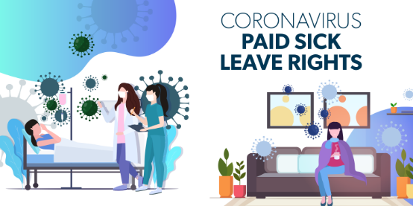
Senate Bill 95 (SB 95) requires employers with more than 25 employees to provide up to 80 hours of COVID-related Supplemental Paid Sick Leave (SPSL) to employees from January 1, 2021 to September 30, 2021.

Public employers must provide notice to employees of their rights to use this new bank of SPSL. This notice may be provided to employees electronically, such as via email. A template notice is being created by the Department of Labor and should be available by the week of April 5, should districts choose to use it.

Public employers must also include this bank of SPSL on employees’ itemized wage statements. SBAS is prepared to provide this leave balance on the employee paystub. It will show as a separate leave balance from sick leave (SL) and vacation (VC) and will be identified as “Supp SL” on the paystub.

District Action Required by April 15
- Each district must follow the steps outlined below in Escape for this new leave balance to be displayed on the employee paystub. Please allow for enough time to thoroughly review leave reports to ensure grant amounts are correct for each employee.

Required setup in Escape outlined below. Please perform these steps in the order described.
- In Escape, setup a new leave code – “SPSL” for supplemental paid sick leave.
- All Orgs must use the same code, the descriptions may be different. The leave balance will appear on the paystub as “Supp SL” (see below).
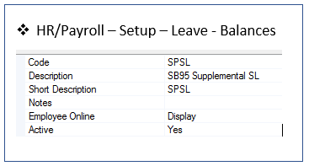
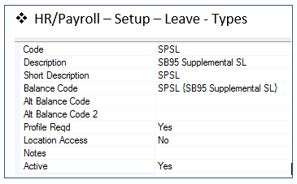

- For each Leave Group, setup the new Leave Balance.

- HR/Payroll – Setup – Leave – Balance Profiles
- See sample of a certificated setup below (Units = days – 10 days based on FTE)
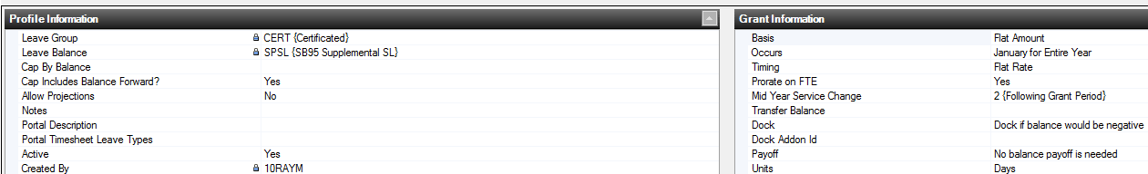

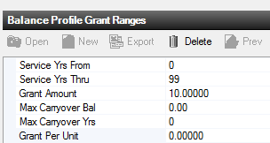

- See sample of classified setup below (Units = hours – 80 hours based on FTE)

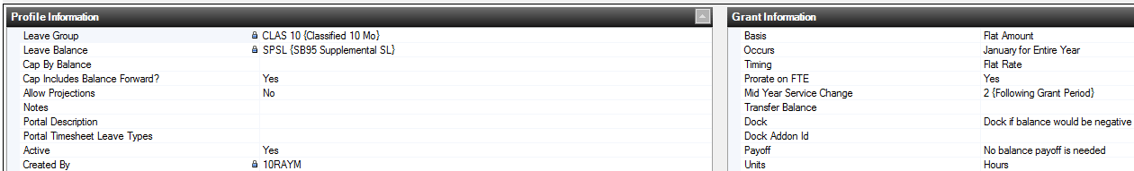
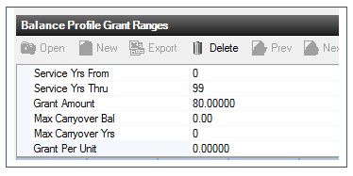

- Next, the SPSL leave will need to be granted.

- HR/Payroll – Employment – Leave Status
  - Open the current month and choose the “Tasks” dropdown and select “Grant”

- Review the leave reports (Leave 01, Leave 03, Leave 10) and Employee Management - Leave tab to verify it granted correctly. If not, review/change Balance Profiles and Grant again. Please contact Myron Porter if you have questions or need assistance with this process.

The allowable reasons for use of this new leave, amount of leave and pay, and rules for retroactivity are outlined in Senate Bill 95 and summarized below. For more detailed information, please refer to the links provided at the end of this document to access the full text of Senate Bill 95 and other helpful resources.

Reasons for Using SPSL Leave

- The employee is subject to a federal, state, or local quarantine/or isolation order related to COVID-19, as defined by an order or guidelines of the State Department of Public Health, the Federal CDC, or a local health officer who has workplace jurisdiction.
- The employee is advised by a health care provider to self-quarantine or self-isolate due to concerns related to COVID-19.
- The employee is attending an appointment to receive a vaccine for protection against contracting COVID-19.
- The employee is experiencing symptoms related to a COVID-19 vaccine that prevent them from working or teleworking.
- The employee is experiencing symptoms of COVID-19 and seeking a medical diagnosis.
- The employee is caring for a family member who is subject to a federal, state, or local quarantine or isolation order related to COVID-19, or who has been advised by a health care provider to self-quarantine or self-isolate due to concerns related to COVID-19.
- The employee is caring for a child whose school or place of care is closed or otherwise unavailable for reasons related to COVID-19 on the premises.

Amount of Leave and Pay
Full-time workers will be entitled to 80 hours of SPSL. Part-time workers will be entitled to a prorated amount of SPSL depending on the circumstances.

SB 95 diverges from AB 1867 and FFCRA in the amount of pay due for SPSL. For non-exempt employees, each hour of SPSL shall be compensated at the highest of the following rates:

- The employee’s regular rate of pay for the workweek in which the employee uses the SPSL, regardless of whether the employee actually works overtime in that workweek.
- The employee’s total non-overtime wages divided by the employee’s total hours worked in the full pay periods occurring during the prior 90 days of employment.
- The state minimum wage or the local minimum wage to which the employee is entitled.

For all employees, SB 95 caps SPSL benefits at the same amount as prior COVID-19-related legislation (i.e., the FFCRA and AB 1867) — $511 per day and $5,110 in the aggregate.

Retroactivity

SB 95 identifies how public employers can process retroactive payments, as follows:

- A public employer must provide an employee with a retroactive payment for the period of leave if:

- the employee took leave on or after January 1, 2021 which would otherwise have qualified as COVID related SPSL under SB 95, and
- the public employer did not provide paid leave (including paying at the rates identified above) to the employee upon oral or written request.

Districts may want to review the following helpful resources from the State of California on COVID-19 leaves:

- Department of Industrial Relations (DIR) - 2021 COVID-19 Supplemental Paid Sick Leave FAQs
https://www.dir.ca.gov/dlse/COVID19Resources/FAQ-for-SPSL-2021.html

- Labor & Workforce Development Agency (LWDA) - https://www.labor.ca.gov/coronavirus2019/

- Labor Commissioner’s COVID-19 Guidance and Resources - https://www.dir.ca.gov/dlse/COVID19resources/

- Senate Bill No. 95 text - Employment: COVID-19: supplemental paid sick leave -
https://leginfo.legislature.ca.gov/faces/billNavClient.xhtml?bill_id=202120220SB95

O:\Payroll\COVID19 SPSL SB95.docx

